GREEN RFP SUBMISSION FORM

Part I- General Information:
Name of Student Organization |  | Team SLAAK, MGT 2354
Contact/Responsible Person |  | Arianna Wright, Lane Robertson Katie Adams, Lauren Scott, and Simar Raheja
Contact Office Held/Title |  | Student Organization
Contact Email Address |  | ariannalw@vt.edu, aro@vt.edu, katie19@vt.edu, laurenscott@vt.edu, simarraheja@vt.edu
Contact Telephone Number |  | 5712457597, 7037867119, 8046906037, 5013883443, 7032493110
Part II- Project Cost Information
Estimated Cost of this Proposal |  | $2,700 | See III.C. below
Estimated Savings - |  | N/A | See III.D. below
Net Cost of this Proposal = |  | $2,700
Part III- Supporting Information

- Please describe your climate action, sustainability, and/or energy initiative and attach supporting documentation.

Description of Project
Our initiative is to build a pollinator friendly garden. This garden will encourage the presence of bees in an effort to raise awareness of the endangerment of bee populations. This garden will educate the Blacksburg community on the importance of bees, pollination, and maintaining pollinator habitats. We are confident that the implementation of this garden will lead to Virginia Tech becoming a certified campus a part of the Bee Campus USA initiative. The garden should be installed along the Huckleberry Trail, this is a location with ample foot traffic but also will not cause any disruption to students or community members. See Appendix item A for an image of the location and then items B though D for a proposed layout of the garden. As seen in item B, there will be an educational component to the garden. This will be a sign which gives information regarding causes for the decline in bee populations, information about why bees are beneficial, and how students can make a change. This sign is listed as item E in the appendix. In addition to this sign, there will be pamphlets available for visitors to take to continue their education and remind them of the importance of saving bees, a draft of this pamphlet can be seen in item F. The goal of this garden is to educate visitors about just how important bees are and the impending issue of bee endangerment, encourage taking preventative steps to ensure that bees do not one day go extinct, and to raise awareness of the issue.

Stakeholder Description
When choosing stakeholders for this project, our group focused on 3 categories: education, campus administrative support, and campus maintenance/landscaping. When looking at education, group members reached out to professors at Virginia Tech, local elementary, middle, and high schools, and girl/boy scout groups. Each of the listed people/groups expressed interest in the educational benefit a project like this offers and were quick to find ways this project could be incorporated into educational activities. Since education is a large component of this proposal, it was important that we garner the support of professors and other organizations which will benefit from the garden. In terms of campus administrative support team members reached out to Jen Friedel for land zoning, Kas Church with VT Engage, among others. Each person interviewed, expressed support for the project and believed it to be of interest to the university. Scott Douglas with the Hahn Horticulture Garden, Janet Scott and Dave Close, Master Gardeners, as well as Jack Rosenberger with the Virginia Tech Grounds Services. Similar to other stakeholders, these people all expressed interest in the project and were in support of the efforts. Jack Rosenberger, would later become our most supportive stakeholder as he is donating all labor and materials on behalf of Grounds Services. In addition to these stakeholders, the BeeKeeping Club at Virginia Tech has offered its full support and has agreed to help with any labor or community outreach. A comprehensive analysis of Stakeholder Interviews can be found in the Appendix under item H.

- How does this initiative help to achieve the goals of the Virginia Tech 2020 Climate Action Commitment Resolution and Sustainability Plan?

This initiative meets goal 10 of the Climate Action Commitment Resolution and Sustainability Plan. Goal 10 calls for integration of the CAC into Virignia Tech’s educational mission through climate action living laboratory (CALL) beginning 2021. This pollinator garden will provide opportunities for Virginia Tech students and members of the Blacksburg community to learn about causes for the declining bee population and solutions. Professors at Virginia Tech expressed interest in the garden and foresaw educational opportunities and benefit from the garden.

3 SMART Goals
Goal #1 - Having organizations, classes, and schools visit the garden
- Specific: We would like 30 organizations, classes, and schools to visit the garden.
- Measurable: We would like to accomplish this in five months.
- Achievable: We intend on having 6 organizations, classes, and schools visit every month. We will have teachers promote the garden through their classes. Additionally, the beekeeping club and the management team who is hired to care of the garden will aid in the marketing efforts.
- Relevant: One of our main priorities of the garden was the educational component and this helps address that overarching goal.
- Time Bounded: The garden is expected to open on September 1st, 2022 so we hope to achieve this goal by January 1, 2023.

Goal #2 - Becoming Bee Campus USA certified
- Specific: Through the implementation and maintenance of the garden Virginia Tech will take the necessary actions to become Bee Campus USA certified.
- Measurable: We will communicate directly with Bee Campus USA twice a month to ensure we are reaching their expectations to become certified and coordinate sessions for them to inspect the facility.
- Achievable: This would be achievable as the garden will be funded by university stipends, universities that make pollinator gardens historically have a positive track record for becoming certified, and we will have the support of an on campus organization (The Beekeeping Club) which will also help our case.
- Relevant: Several Virginia Tech stakeholders have told us that becoming Bee Campus USA certified is of great interest to the university.
- Time Bounded: We would like to become certified by September 1st 2023.

Goal #3 - Have a majority of the flowers bloom by the time pollination season begins
- Specific: We anticipate to have 50% of all flowers bloom prior to the start of the fall pollination season
- Measurable: We will monitor the garden's progress every week in the summer to ensure that the flowers are on track to bloom. Additionally, we will implement certain techniques to accelerate the process such as deadheading.
- Achievable: This will be realistic as once our garden gets approved in mid April we will have the flowers planted by no later than June 30th. This will provide ample time for the flowers to bloom as seeds generally take 95 days to flower.
- Relevant: The garden needs to have aesthetic appeal to draw in visitors, encourage them to stop and learn more about our garden, and by extension spread awareness about the significance of bee conservation. Additionally, the garden needs to have a considerable amount of fully bloomed flowers to attract local pollinators and foster bee populations.
- Time Bounded: We would like the flowers to bloom by the fall pollination season which aligns with the garden initial opening of September 1st 2022.

- What is the cost of your proposal? Please describe in adequate detail the basis for your cost estimate.

Budget
The total cost of the project is expected to be $2,700. The actual cost may fluctuate, accounting for a 20% contingency. Maintenance will be annual and the pamphlets will need to be reprinted as needed. Every other cost should be fixed and should not reoccur. The budget attached below:
Soil Tilling = $200
Native Pollinator Mix (seeds) = $250
Annual Ryegrass = $75
Educational sign = $1,500
Pamphlets = $116 (250 bifold brochures)
Concrete = $100
Contingency = $459
Grand Total = $2,700

Risks/Concerns
Risks associated with this proposal are the potential harm that the bees could cause to visitors and vandalism. While it is true that the bees this garden will attract have the ability to sting humans, they will not do so unless provoked. There will be adequate information on the interpretive sign and the pamphlets which tell visitors that the bees will not bother them unless they bother the bees first. There is also the risk that vandalism may occur from Virginia Tech students or other community members. The interpretive sign and the pamphlets will have garden etiquette stated but in the event that people ignore the etiquette, administration will be alerted to any disruptions to the garden as they occur after maintenance on the garden. Maintenance is budgeted for 10 hours per week, over the course of multiple days, maintenance will have a presence multiple times per week so it can be assumed that administration will be alerted to the disruption shortly after its occurrence.

- Will your proposal produce cost savings for the university? If so, how much? Please describe in adequate detail the basis for your savings estimate.

The pollinator garden will not generate any cost savings for the university. While this project will not generate money, we are confident it will help Virginia Tech become certified as a part of Bee Campus USA, which allows the university to be eligible for grants and external sources of funding.

- Is this funding request for a one-time need or an ongoing need (please mark one)?
One-Time _X____ Ongoing _____

- Is funding available for this request from another source? If yes, describe the funding (source, amount, etc.).

Other Sources of Funding
The Virginia Tech Grounds Services have agreed to donate all labor and materials. This includes soil testing, landscaping fabric, landscaping consultation, fertilizer, and mulch. Bee campus USA committee volunteers will also help with periodic weeding.

GREEN RFP SUBMISSION FORM
(Continued)

Part IV- Requestors/Reviewers
Prepared By (Name of Contact for Student Organization)  Arianna Wright, Lane Roberston, Katie Adams, Simar Raheja, and Lauren Scott |  | Date 11/18/2021
Jack Rosenberger  Matt Gart  Reviewed By (Name of Appropriate University Official)  Nathan King  Reviewed By (Name of Office of Climate Action, Sustainability, and Energy Representative) |  | 12/7/21  Date  12/3/21  Date

GREEN RFP SUBMISSION
CONTACT LIST

In the preparation of your Green RFP form, student organizations are encouraged to seek input and guidance from the following list of university employees. These individuals are familiar with the form and the process. They can address the feasibility of your proposal, provide a technical review, and evaluate the cost & potential savings.

Area of Expertise | Name | Title | Email Address
Engineering & Operations, Energy Management | Steve Durfee | Campus Energy Manager | sdurfee@vt.edu
Facilities: Housing & Residence Life | Todd Pignataro | Associate Director of Facilities | ptodd@vt.edu
Facilities: Buildings & Grounds (Small Renovations) | Jim McDaniel | Project Coordinator | jmcdani@vt.edu
Exterior Lighting | Matt Hagy | Associate Director of Utilities | mhagy1@vt.edu
Student Engagement & Campus Life | Spencer Stidd | Associate Director for Event Services | sstidd@vt.edu
Dining Services & Housing (Student Affairs) | Blake Bensman | Sustainability Manager | bensman@vt.edu
Alternative Transportation (Bus, Bike, & Walk/EVs) | Nick Quint | Transportation Network Manager | nquint@vt.edu
Landscape Architecture | Jack Rosenberger | Campus Landscape Architect | jrosenb@vt.edu
Hahn Horticulture Garden | Scott Douglas | Director/Instructor | dsd1@vt.edu
Recycling & Waste Management | Teresa Sweeney | Program Consultant | msrecycle247@vt.edu
Other Sustainability Topics | Nathan King | Campus Sustainability Manager | naking@vt.edu

Arianna Wright, Lane Roberston, Katie Adams,
Simar Raheja, and Lauren Scott
MGT 2354
Green RFP Final Report: Pollinator Garden
Appendix

Item A: Location of the proposed pollinator garden
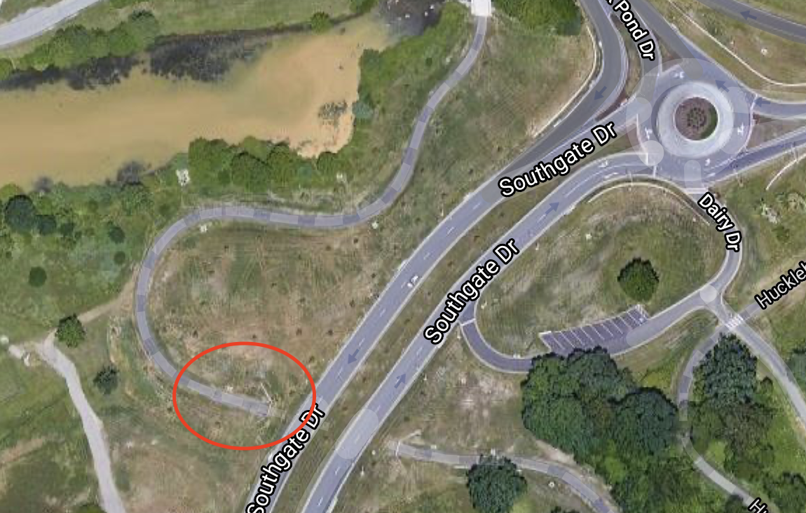

Item B: Proposed layout of the pollinator garden - birds eye view
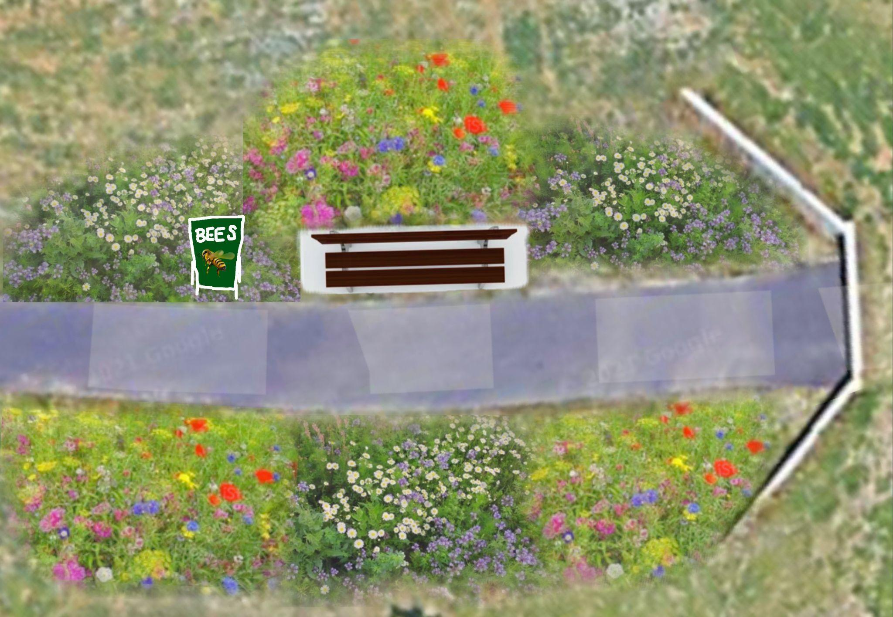

Item C: Proposed layout of the pollinator garden - landscape view
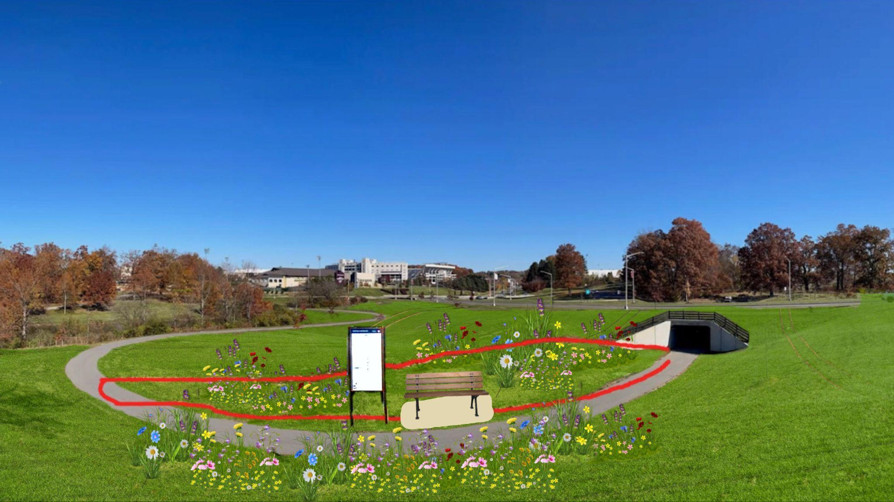

Item D: Itemized layout description of the pollinator garden
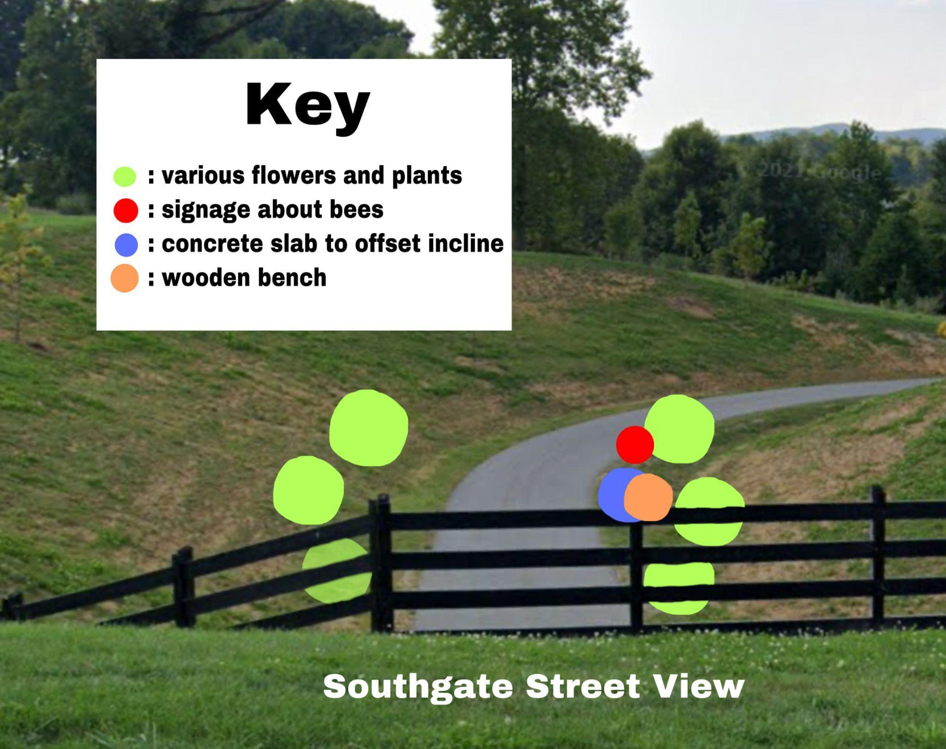

Item E: Educational Sign
Below is a mock up of what this educational sign may say and some suggestions as to what should be included to ensure educational benefit and garden etiquette.
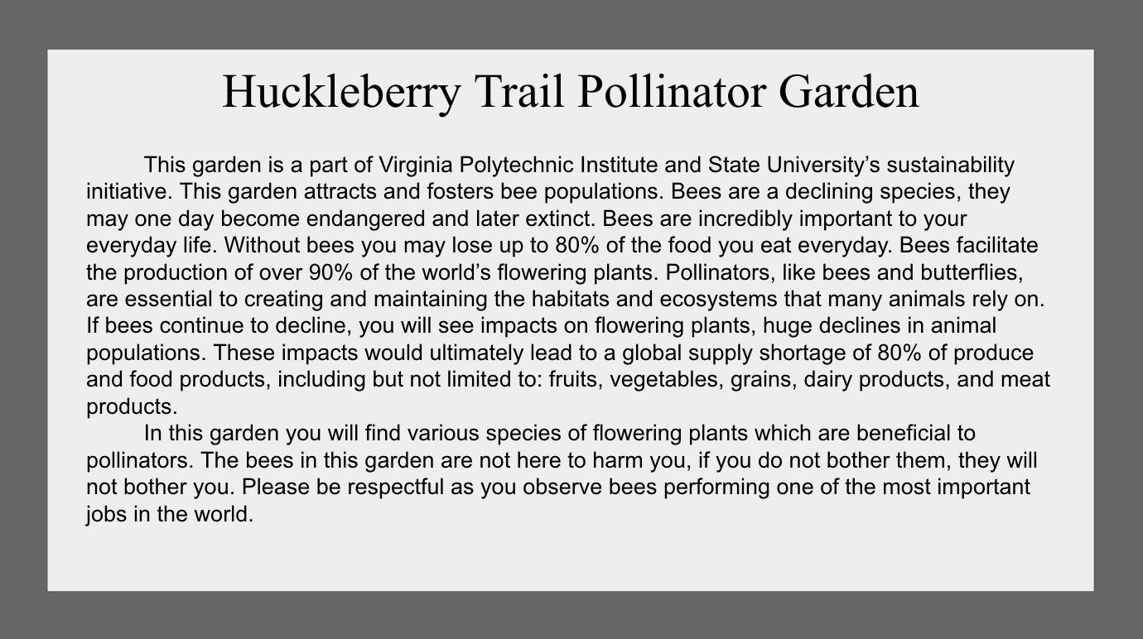

Item F: Trifold Brochure
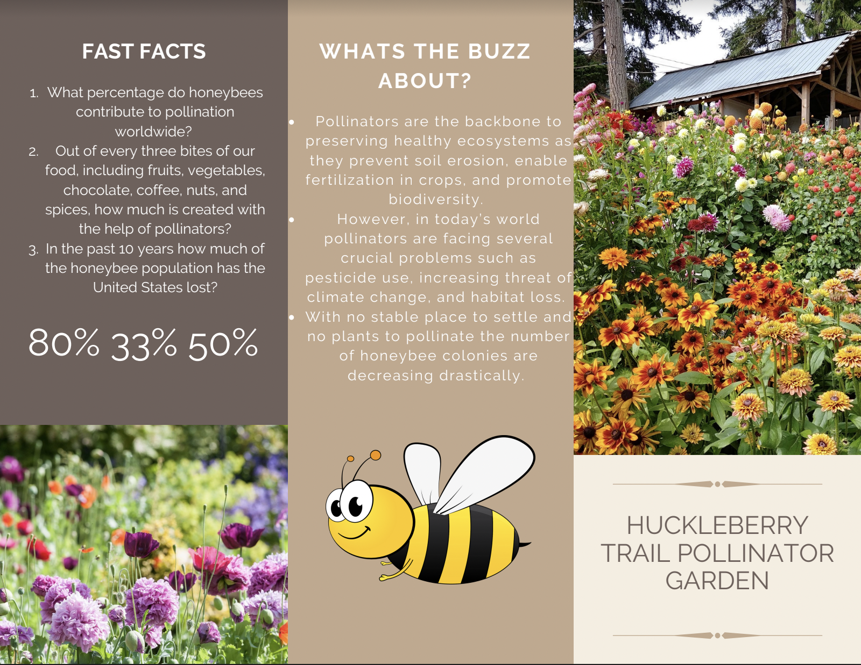
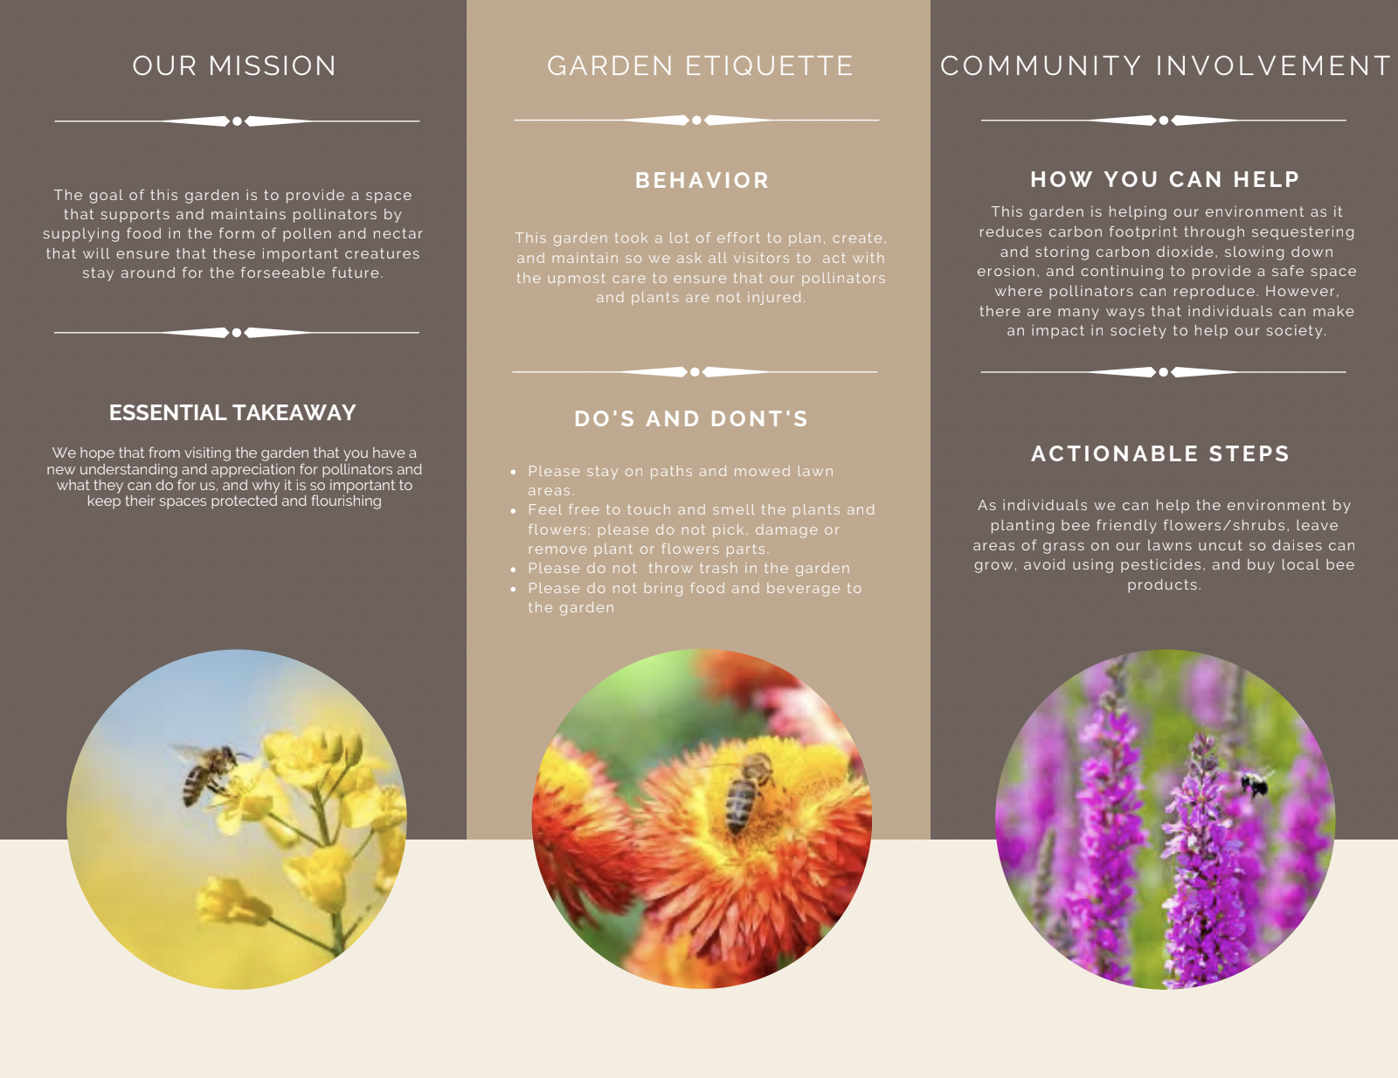
Front Back
A pdf of this brochure will be attached to the email submission.

Item G: Background Research
Bees, plants, and community involvement are the necessary components for building a welcoming habitat that encourages the community to learn more about pollination. For this RFP proposal, it was critical to identify Virginia Tech’s motives surrounding bees, observe how other universities have implemented pollination sites on their campuses, and identify some of today’s crucial statistics regarding bee species.

It is vital that we equip our garden with the right resources to allow for year round sustainability and an educational benefit to visitors. The research we compiled for this proposal overviews bees in general, as well as why designated pollination spaces are important and the statistical backings behind them. The overarching insight we gained was about the diversity among bees, just how prevalent pollinators are, the use of pesticides, and interesting components from other universities that are backed by Bee Campus USA.

Bee Overview
While targeting the bee population it is important we address their species, commonalities, and lifestyle. When people hear the word “bee” they often think of a single bee species, commonly the European honey bee. But actually, there is significant diversity among bees! The United States is home to just over 3,600 native (wild) bee species such as bumble bees, leafcutter bees, sweat bees, mason bees, longhorn bees, and mining bees. There are over 20,000 species globally. Stingers among bees can cause a scare for some, but the vast majority of native bees are solitary and rarely sting. Most stings are from non-native honey bees and wasps. The stinger is an adaptation of the ovipositor (egg laying anatomy), which is only present in female bees, making male bees unable to sting. Teaching people about the diversity of bees, and how unlikely it is to be stung by a solitary native bee, is a great way to make people more interested in and comfortable with bees. This would allow for more traction to our garden and less avoidance.

Pollination Specifics
According to the U.S. Forest Service pollination is the act of transferring pollen grains from the male anther of a flower to the female stigma. Pollinators are keystone species in essentially every terrestrial ecosystem on earth, assisting in plant reproduction and supporting other species of wildlife. Native pollinators are particularly important because they evolved alongside native plants and in many cases are the most effective pollinators. Out of every three bites of our food, including fruits, vegetables, chocolate, coffee, nuts, and spices, 33% is created with the help of pollinators, because of this eye opening statistic it was important for our team to find a way to increase pollination among the Virginia Tech Campus while also providing educational elements and a beautiful addition to the community. Research has shown significant declines in native pollinator population sizes and ranges globally. In fact, up to 40% of pollinator species on earth may be at risk of extinction in the coming years as a result of habitat loss, pesticide use, and climate change. Contamination resulting from the extensive use of pesticides has been tied to the decline of species important to ecosystems, including pollinators.

Lack of Habitat
For frequent pollinators, the lack of habitat has posed a significant issue as of late. Over millions of years, plants and pollinators have relied on each other for survival. In the United States, non-native plants dominate ornamental landscapes, largely because they tend to attract fewer unwanted insects. Because the horticulture industry has become adept at improving species that were native to the United States, this process often leads to a reduction in the quality of pollen and nectar, or the loss of pollen and nectar altogether. While some exotic or hybridized species supply adequate nectar, native pollinators primarily rely on native plant species. Plant wholesalers and retailers tend to grow mostly exotics, hybrids, and named cultivars that may or may not provide the food and nesting sources native pollinators rely on. These plants are often treated with pesticides, many of which harm pollinators.

Pollination Habitats at other universities
- Southern Oregon University
-The campus boasts more than a dozen pollinator gardens
-SOU professors have taken students out to create bee habitats for the campus farm and to collect native flower seeds to sow in the arboretum.
- College of San Mateo
-They have the CSM Community Garden honoring Cesar Chavez, famed farm labor leader and civil rights activist. This serves as the centerpiece of the pollinator program and campus itself.
-The garden is filled with native plants like white sage, which are used both by pollinators for sustenance and student cultural groups for ceremonies.
- University of North Carolina Asheville
-Nearly every nook and cranny of campus has been filled with native plants, bee hotels, and edible landscaping.
-Professors collaborate closely with the grounds department to use the campus as an “outdoor laboratory” for pollinator-related classes and student research projects.
-Students are also involved with pollinator-oriented community outreach programs and guided tours of the Bee Hotel.

Bee City USA / Bee Campus USA
- Bee City USA provides a framework for communities to come together to conserve native pollinators by providing them with a healthy habitat that is rich in a variety of native plants, provides nest sites, and is protected from pesticides.
- The focus of Bee City USA is bees, and primarily our native species. The steps that affiliates take to conserve our native bees, including creating safe habitats and hosting community events, will also help other pollinators including butterflies and moths as well as the non-native honey bee. ​
- Bee Campus USA affiliates make commitments to conserve native pollinators. Students, faculty, administrators, and staff work together to carry out these commitments and make their campus a better place for pollinators.
- Bee Campus USA currently has 274 affiliates consuming 44 states and four representatives within the state of Virginia including UVA, JMU, University of Richmond, and Randolph College

Item H: Stakeholder Takeaways
Our group interviewed a diverse network of individuals when gathering insight about our Green RFP proposal.This allowed us to gain insight from stakeholder groups such as students, professors, maintenance staff, and gardening specialists. From students and professors we gathered lots of interest in using our educational garden as both a teaching tool and an opportunity for volunteer work within the community. We talked extensively with stakeholder student groups like the Virginia Tech Beekeeping Club to make sure we included their vision for the school into our proposal. Speaking with professors helped us decide on the educational content of our signage and pamphlets. For example, we chose to center our content around raising awareness about the significance of bees and bee habitat conservation. We felt it was more important to teach garden visitors about the purpose of the garden, as opposed to teaching them about the content of the garden such as the specifics on the pollinator mix we used.
Initially our team had envisioned planting lots of trees and flowers within our garden. However, we didn’t know which species to buy and which ones grow well together. After talking with various gardening experts such as Master Gardeners, we learned to focus on perennial and native plants. We also learned more about the benefits of using a pollinator mix as opposed to flowers and trees. This insight helped us alter our garden design so that it was based on pollinator mix instead of flowers. In doing this, our garden is more self-sustainable and we can reduce costs by no longer needing to budget for the continuous replacement of flowers and plants.
We also spent a lot of time talking with Virginia Tech maintenance and gardening staff about the logistics of our garden. We met with stakeholders such as Scott Douglas and Jack Rosenberger to discuss potential garden locations and set ups. One of the biggest concerns they brought to our attention was the long term maintenance and upkeep of the garden. For example, determining who would be responsible for checking on the plants and making sure the garden is in good condition. We resolved this issue by deciding to hire a student worker to monitor the garden a few times a week. This cost was then accounted for in the maintenance section of our budget. In addition, through our team’s stakeholder interviews we also realized that our previous proposed garden locations were either too expensive or consisted of plots of land that were too big to develop. Meeting with stakeholders helped us decide to place our garden along the Huckleberry Trail since it already has high traffic and would increase our chances of spreading bee preservation awareness.

Item J: Work Breakdown Structure
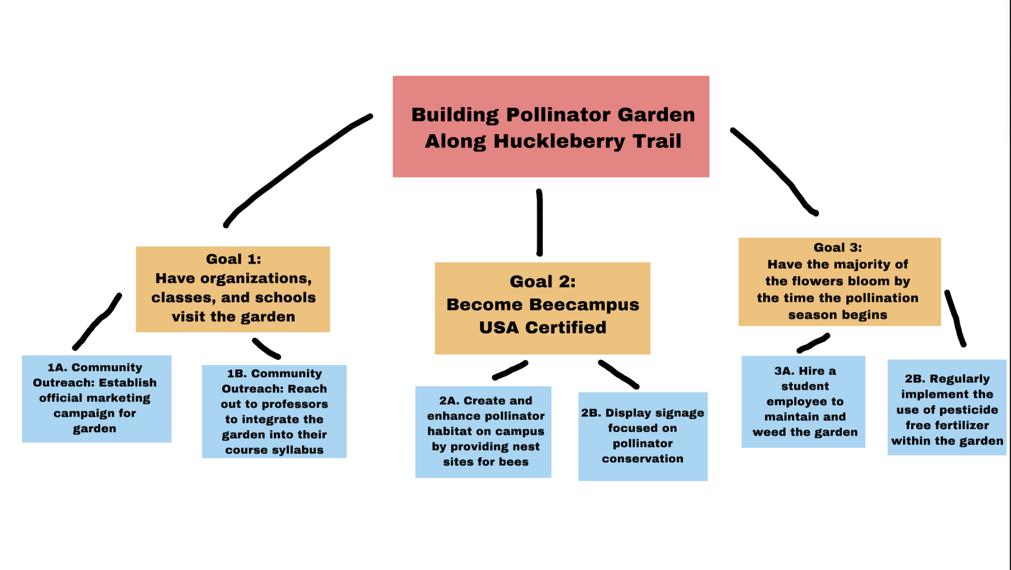

Item K: Tentative Schedule
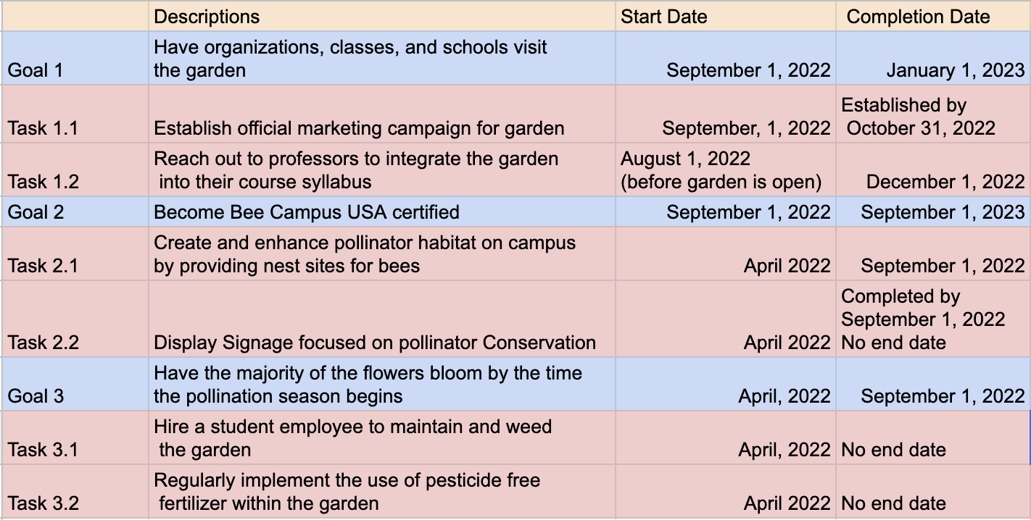

Bibliography
Bee campus. Bee Campus | Sustainability & Carbon Solutions. (n.d.). Retrieved November 10, 2021, from https://sustainability.berkeley.edu/engage/bee-campus.
Bee Campus USA Commitments. Bee City USA. (2021, June 16). Retrieved November 10, 2021, from https://beecityusa.org/bee-campus-usa-commitments/.
Current Bee Campus USA affiliates. Bee City USA. (2021, October 28). Retrieved November 17, 2021, from https://beecityusa.org/current-bee-campus-usa-affiliates/?search_9358e=Virginia&sort_9358e=State.
Hahn Horticulture Garden. College of Agriculture and Life Sciences | Virginia Tech. (2020, August 23). Retrieved November 9, 2021, from https://www.cals.vt.edu/make-a-gift/hhg.html.
Latest news. Muhlenberg College. (n.d.). Retrieved November 10, 2021, from https://www.muhlenberg.edu/news/2021/perennialsandpollinators.html.
Museum, C. A. and F. (n.d.). The importance of bees: Pollination: Bees a honey of an idea. The Importance of Bees: Pollination | Bees A Honey of an Idea. Retrieved November 17, 2021, from https://bees.techno-science.ca/english/bees/pollination/default.php.
Planting a pollinator garden. Love Your Landscape.org. (n.d.). Retrieved November 9, 2021, from https://www.loveyourlandscape.org/expert-advice/eco-friendly-landscaping/designing-your-landscape-for-wildlife/planting-a-pollinator-garden/.
Plants. Bee City USA. (2021, June 16). Retrieved November 17, 2021, from https://beecityusa.org/plants/.
U.S. Department of the Interior. (n.d.). Pollinators in trouble. National Parks Service. Retrieved November 17, 2021, from https://www.nps.gov/subjects/pollinators/pollinators-in-trouble.htm.
Vistaprint.com. (n.d.). Retrieved November 9, 2021, from https://www.vistaprint.com/marketing-materials/brochures?couponAutoload=1&GP=11%2F02%2F2021%
Wahlstrom, D. T. (2020, June 15). Diversity in the sports industry. The Sport Digest. Retrieved November 15, 2021, from http://thesportdigest.com/2020/06/diversity-in-the-sports-industry.
14 pollinator-friendly colleges that have us buzzing. Sierra Club. (2018, October 16). Retrieved November 17, 2021, from https://www.sierraclub.org/sierra/cool-schools-2018/bee-campus-usa-pollinator-friendly-college-university.

