GREEN RFP SUBMISSION FORM

Part I- General Information:
Name of Student Organization |  | UAP 3354- Environmental Policy and Planning
Contact/Responsible Person |  | Lindsay Bomgardner, Emma Pausley, Mary Shelly
Contact Office Held/Title
Contact Email Address |  | Lindsayb01@vt.edu emmapausley@vt.edu maryhudsons@vt.edu
Contact Telephone Number |  | 5188591831
Part II- Project Cost Information
Estimated Cost of this Proposal |  | $78,200 | See III.C. below
Estimated Savings - |  |  | See III.D. below
Net Cost of this Proposal = |  | 78,200 | $92,000 actually approved*
Part III- Supporting Information

- Please describe your climate action, sustainability, and/or energy initiative and attach supporting documentation.
Our sustainability initiative focuses on the further restoration of Stadium Woods, an old growth
forest located on Virginia Tech's campus. We would like to fund a one time project to install
multiple barriers to reduce traffic through non-marked areas. It is used as a classroom, a training
area for the Corps of Cadets, and a place of outdoor enjoyment by many. Old growth forests are
also important for the ecosystem services they provide, including their high ability to sequester
carbon. With the implementation of our proposal, Stadium Woods will be restored to its best
state and therefore will be able to offer the beneficial ecosystem services that old growth forests do.
1. Install multiple barriers
a. We propose the installation of guard barriers along the boundary of the woods that
meets Center St. The goal of the barriers is to keep heavy traffic that comes
along with Center St. tailgates during football season.
https://roanoke.com/news/local/outside-virginia-techs-lane-stadium-another-turf-battle-continues/article_91205ef2-2873-11ec-a817-6b337f0783a4.html

- How does this initiative help to achieve the goals of the Virginia Tech 2020 Climate Action Commitment Resolution and Sustainability Plan?

Goal 6 of the 2020 Climate Action Commitment Resolution and Sustainability Plan: “Agricultural, forestry and land use operations go carbon neutral by 2030”
- One potential pathway under this goal is to “manage Virginia Tech trees, forests and woodlands to increase carbon sequestration and provide additional environmental benefits”. The restoration of Stadium Woods would improve its ability to sequester carbon from the atmosphere, and provide additional environmental benefits such as increased biodiversity, wildlife habitat, and water and air purification. A

Attachment # 2
- What is the cost of your proposal? Please describe in adequate detail the basis for your cost estimate.

Install 1,700 feet of 2 rail wooden guardrail ($40/linear foot) = $68,000
15% contingency = $10,200
Total Cost = $78,200

- Will your proposal produce cost savings for the university? If so, how much? Please describe in adequate detail the basis for your savings estimate.

This proposal will not produce monetary savings for the university.

- Is this funding request for a one-time need or an ongoing need (please mark one)?

One-Time __X__ Ongoing _____

- Is funding available for this request from another source? If yes, describe the funding (source, amount, etc.).
N/A

GREEN RFP SUBMISSION FORM
(Continued)

Part IV- Requestors/Reviewers
Emma Pausley, Lindsay Bomgardner, Mary Shelly  Prepared By (Name of Contact for Student Organization) |  | Date: 11/17/21
Jamie King  Reviewed By (Name of Appropriate University Official)  Nathan King  Reviewed By (Name of Office of Climate Action, Sustainability, and Energy Representative) |  | 12/7/21  Date  12/3/21  Date

Supporting Documents:

Forest Management Plan: Virginia Tech Stadium Woods
Written by: Frank J. Daig, Jr., Ian T. Foley, Ryan M. Mullaney
Date: 05/03/2013

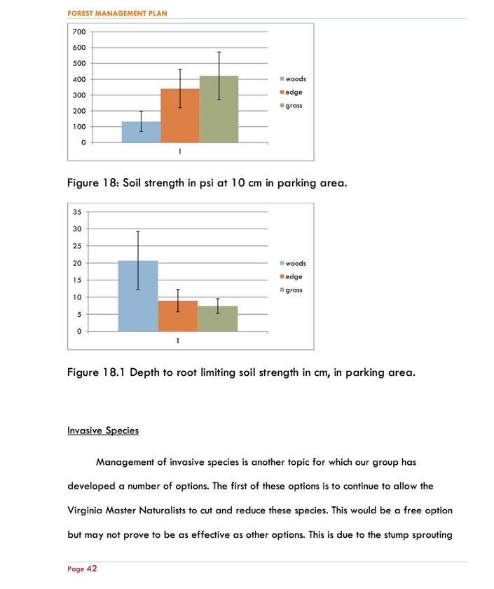
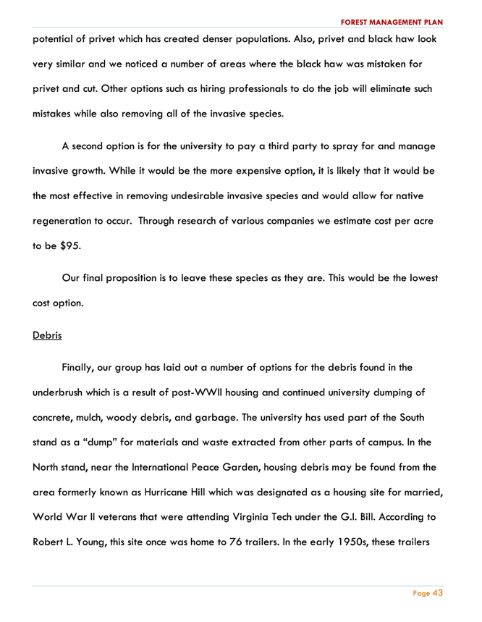
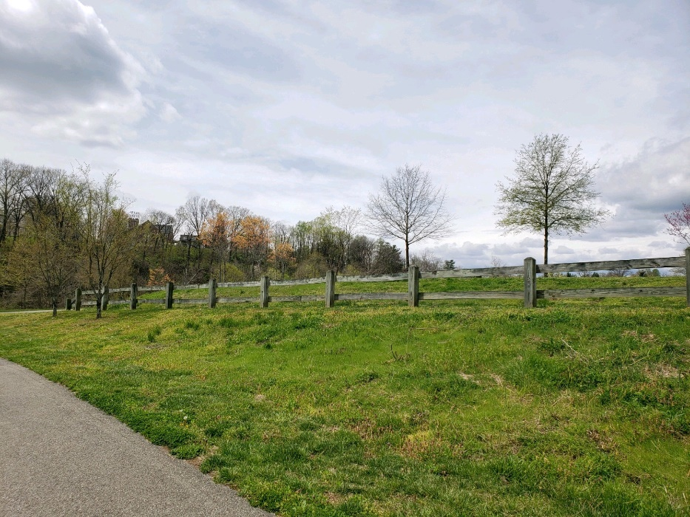
Proposed Guardrail design
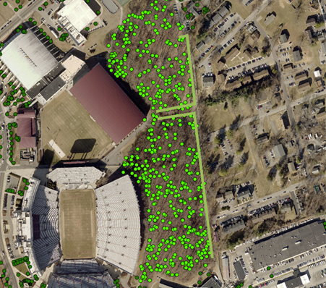
Proposed fencing layout

